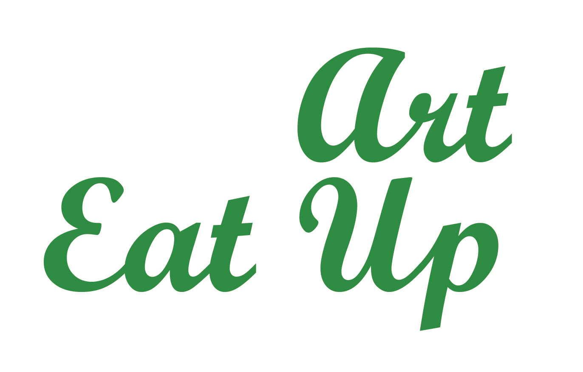
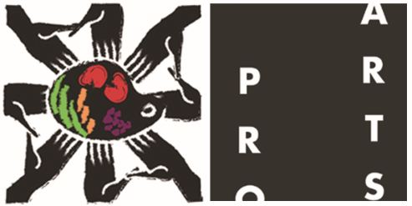
Contact: 201-736-7057 arteatup@gmail.com

Call for Proposals!
Friday March 9th, 2012 Art Eat-Up
Hamilton Square 1 McWilliams Place, 6th Floor
Jersey City, NJ (Art House )
7-10pm

Submission Guidelines:

Fill out the form on page 3 and 4 to enter and email it as an attachment to: arteatup@gmail.com
Attach any jpegs in your email. Incomplete proposals will not be accepted. Proposals must be submitted by February 13, 2012 in order to participate. Email with any questions. For more information, check the Art Eat Up website:

http://www.proartsjerseycity.org/events/art-eat-up/

Accepted proposals are free to Pro Arts members. Nonmembers whose proposals are accepted must pay a $25 fee, which entitles them to a one-year membership in Pro Arts Jersey City, a ballot and a beverage cup. For information on the benefits of Pro Arts membership please visit our website www.proartsjerseycity.org

More Info:
- Project proposals can be for artwork that will manifest itself in ANY media. However, projects must be considered ‘visual art’ and demonstrate feasibility for completion of the proposed project.
- Any individual artist or groups of artists are eligible to apply for participation as an Art Eat-Up artist, including non-Pro Arts members. One project proposal per person.
- No more than 10 projects will be on display at any one Art Eat-Up, 5 in the Individual Project Category and 5 in the Group Project Category. If more than 5 projects are submitted per category, the event committee will select the top 5 from each category to participate in the March 9th Art Eat up Event.
- At the March 9th ART EAT UP event, attendees will each be given 2 ballots, one to vote for their favorite Individual Project and one to vote for their favorite Group Project.
- Each artist will be given one table to display their project, and will have the opportunity to present their project during the event. Artists who submit must be present at the event.
- At the end of the evening the ballots will be tallied. Grants will be awarded to the recipients of the highest vote in each category. One grant to an Individual Project and one grant to a Group Project.
- The grants are an unrestricted financial resource to realize a visual arts proposal. However, artists must indicate how they will use a grant in their proposal and in their project display.
- Grants are awarded to help artists realize projects that they want to create. Grants are not for projects that are already completed.

- Winning projects will be documented throughout their creation and realization at the following Art Eat-Up, on the website, blog, and FYI newsletter.

*************************************************************************************
Art Eat-Up is a grants process that gives an artist an unrestricted financial resource to realize a visual arts proposal, whether it is for one piece or an entire body of work. The grant may provide materials, equipment or even living expenses while the artist completes the project. It provides artists the opportunity to begin marketing their work before it is made. It creates momentum and awareness for art projects promoted during the event and possibly realized with the help of the Art-Eat-Up grant.

Art Eat-Up is grassroots funding at its best: donations for the community dinner go directly to funding art-makers whose proposals draw the most votes from the diners. Community participation in the grant selection process is the key: through this process we hope to stimulate and support experimental, critical and imaginative projects that may not be eligible for formal funding. It helps connect artists with artists, artists with the community, and the community with each other during Art Eat-Up dinners.

Submission Form
March 9th, 2012 Art Eat-Up *
Hamilton Square 1 McWilliams Place, 6th Floor Jersey City, NJ, 7-10pm

*************************************************************************************

Name of artist(s): Email & Phone:

Title of project:
Project Summary:

How will you use the grant towards your project (about $500-$1000?):

How will this project manifest itself in the 2012 Studio Tour (encouraged) and at the next Art Eat Up?

Why is this project critical?

Please attach 3 visuals in low-res jpeg format. Sketches and/or images of similar previous work are acceptable.

